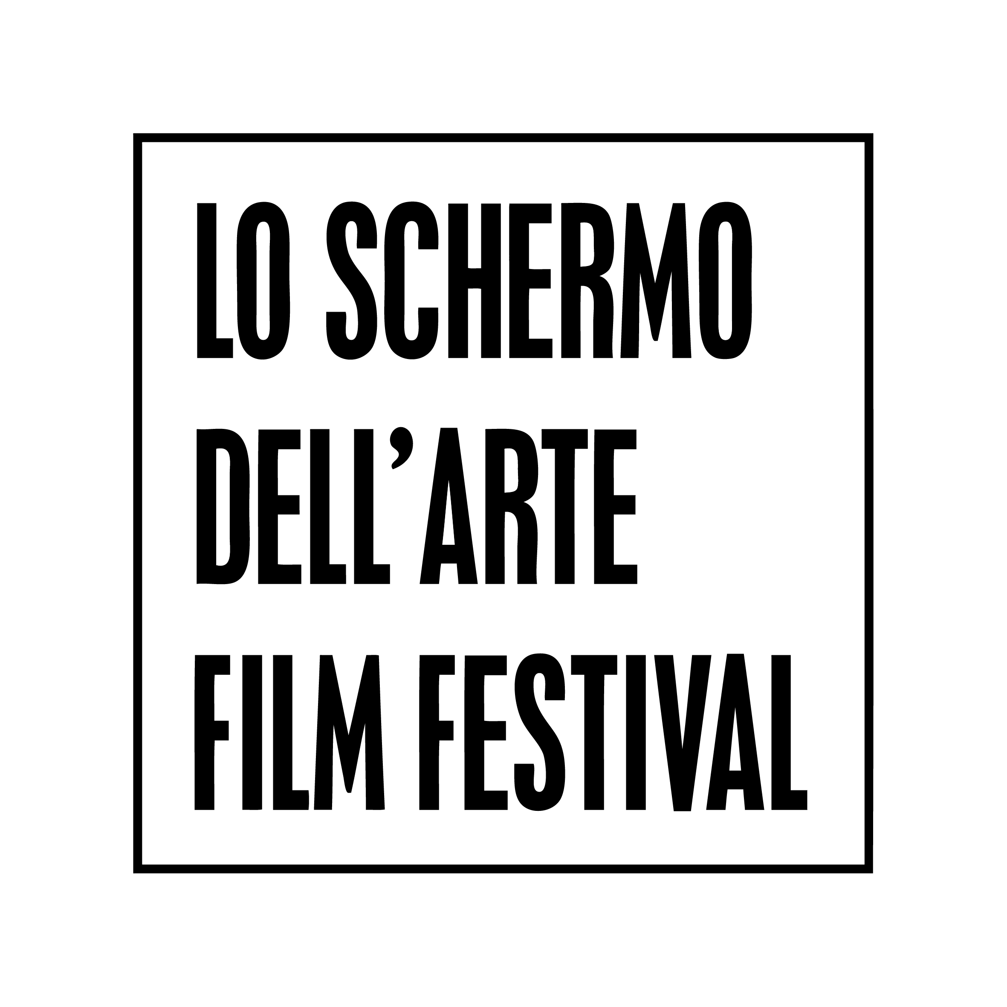

VISIO - European Programme on Artists’ Moving Images
4th Edition
(Florence, 17th -22nd November 2015)

APPLICATION FORM

Deadline:
Monday, September 21st, 2015, 11:00 p.m. (Italian Time). Late entries will not be considered.

Complete Applications must be sent to Maria Hernández Torres at visio@schermodellarte.org

The 12 selected candidates will be notified by Monday October 5th, 2015 at the latest.

Requirements:

Candidates must be visual artists who:

- work with moving images as part of their artistic practice
- are under 35 years old
- are citizens or residents of one of the 47 member countries of the European Council (for the complete list, see http://www.coe.int/en/web/portal/47-members-states)
- have a degree (M.A. or equivalent) or have had at least a solo-show in the last two years
- have an excellent knowledge of the English language

Personal details

Full Name:
Address:
Country of residence:
Nationality:
Date of birth:
E-mail:
Phone number:
Skype:
Website / Blog:

Where did you hear about VISIO - European Programme on Artists’ Moving Images?

Professional details

Short biography in a narrative form (no more than 900 words):

Web links to relevant previous works (full length):

Introduction Letter:

Why would you like to join VISIO - European Programme on Artists’ Moving Images? (no more than 2000 words):

Terms and Conditions:

If selected for the VISIO Program I hereby authorize Lo schermo dell’arte Film Festival to include, without any loan or screening fee, one of my video work or video installation in the exhibition VISIO. Next Generation Moving Images at Strozzina, Palazzo Strozzi (17th Nov – 20th Dec, 2015). The exhibition display and the selection of the work for the show will be discussed together with the curator Leonardo Bigazzi.

Furthermore I declare that if selected I’m able to support my travel to Florence through a grant or my private funds and to attend the Programme from Tuesday November 17th to Sunday November 22nd.

I declare that I own the rights of use for the submitted materials and that this does not collide with the rights of other third parties or collecting societies.

I authorize Lo schermo dell’arte Film Festival to use the materials (images, texts, video excerpts if not protected by password) for any promotional purposes in connection with VISIO - European Programme on Artists’ Moving Images and its activity, which may include: exhibition catalog, publications, website, press releases, social media. I consent and authorize the use of the personal data, in accordance with Legislative Decree on Privacy (196/03).

I hereby confirm and accept all the above terms and conditions.

Date

E-signature

Please note that together with this Application Form you need to submit also the following files/documents in order to complete your application:

- Complete Curriculum vitae
- Portfolio with web links to previous video works and, if available, exhibition photos
- One photograph of the artist with a resolution of at least 300 dpi (format: JPG or TIFF)

